1. SALES BY CUSTOMER:

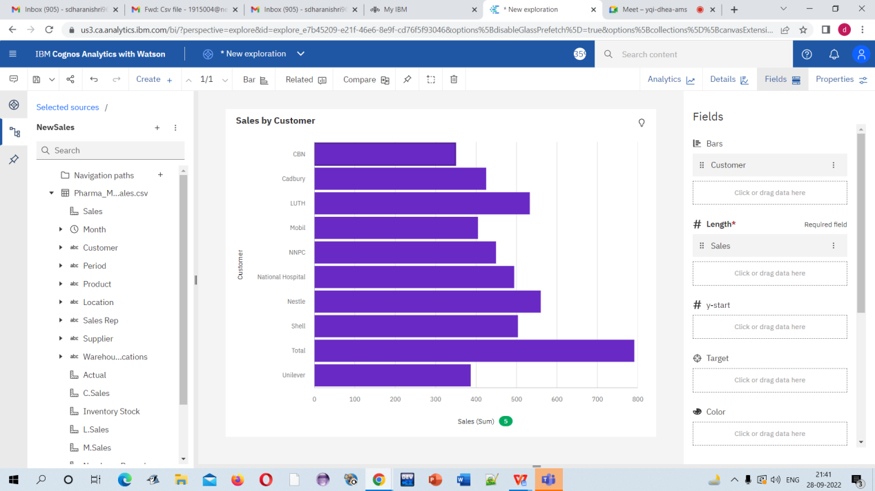

LINK

<https://us3.ca.analytics.ibm.com/bi/?perspective=explore&pathRef=.my_folders%2FSales%2Bby%2BCustomer&subView=model0000018384dabd32_00000004>

1. SALES BY LOCATION:

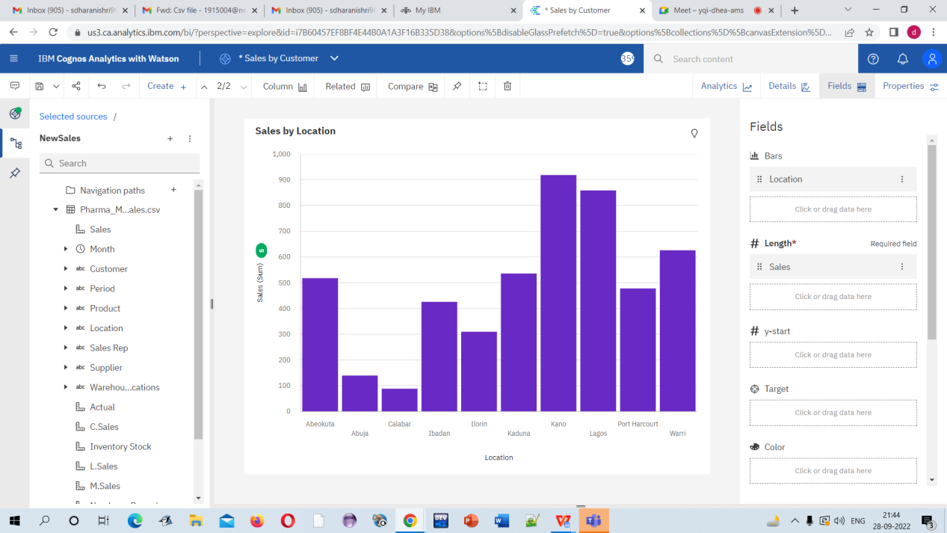

LINK:

<https://us3.ca.analytics.ibm.com/bi/?perspective=explore&pathRef=.my_folders%2FSales%2Bby%2BLocation&subView=model0000018384e00c1f_00000003>

1. SALES BY SALES REPRESENTATIVE:

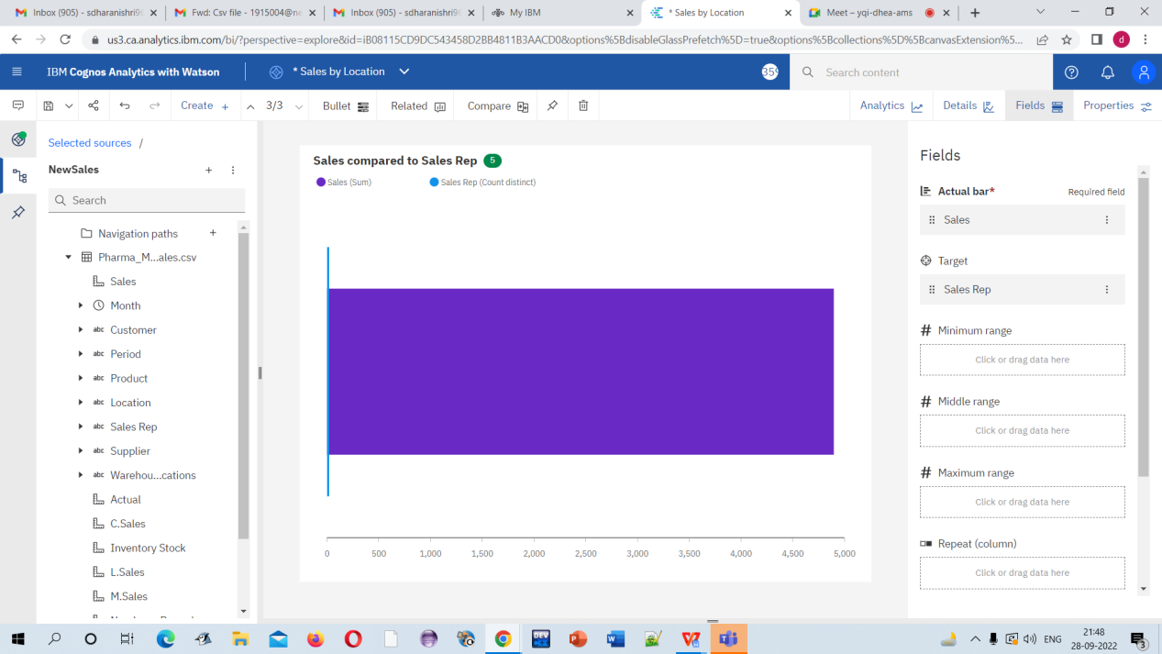

LINK:

<https://us3.ca.analytics.ibm.com/bi/?perspective=explore&pathRef=.my_folders%2FSales%2Bcompared%2Bto%2BSales%2BRep&subView=model0000018384e17e25_00000000>

1. RECEIVED INVENTORY FROM SUPPLIER:

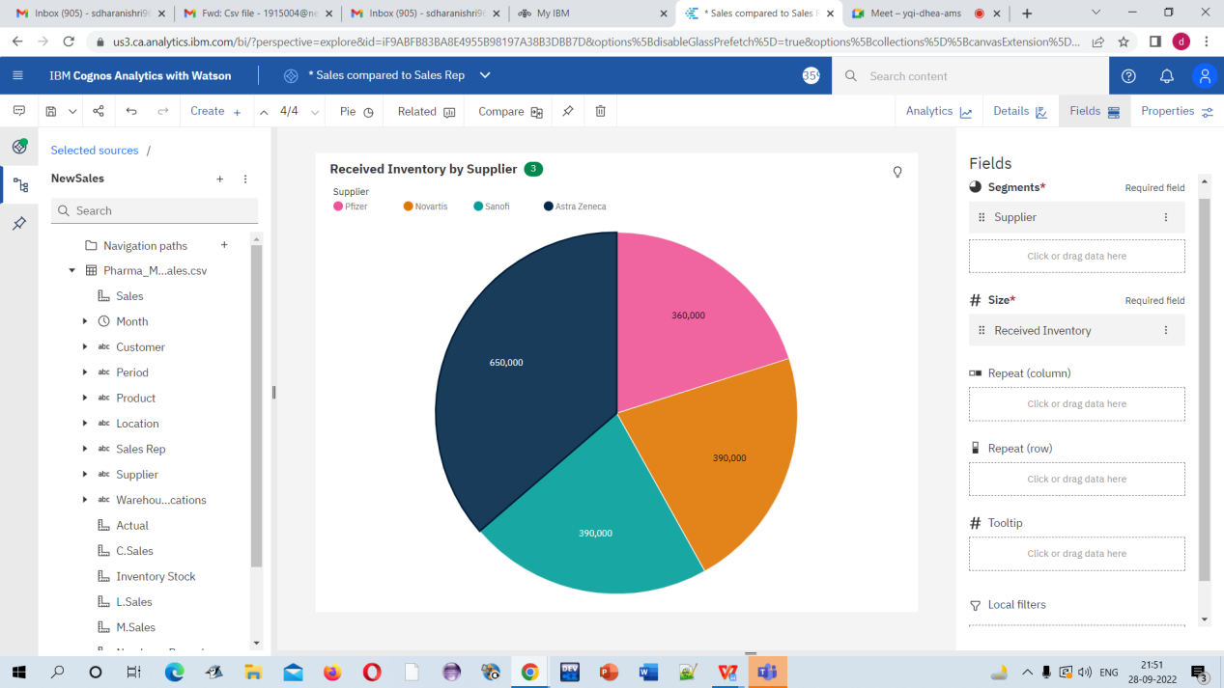

LINK:

<https://us3.ca.analytics.ibm.com/bi/?perspective=explore&pathRef=.my_folders%2FReceived%2BInventory%2Bby%2BSupplier&subView=model0000018384e64d13_00000004>

5.INVENTORY STOCK FOR WAREHOUSE LOCATIONS:

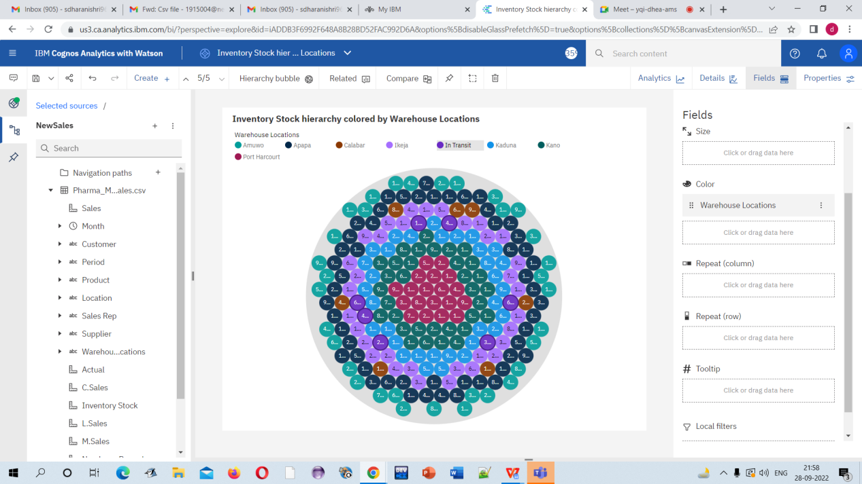

LINK:

<https://us3.ca.analytics.ibm.com/bi/?perspective=explore&pathRef=.my_folders%2FInventory%2BStock%2Bhierarchy%2Bcolored%2Bby%2BWarehouse%2BLocations&subView=model0000018384e8d687_00000001>

1. SALES BY C SALES:

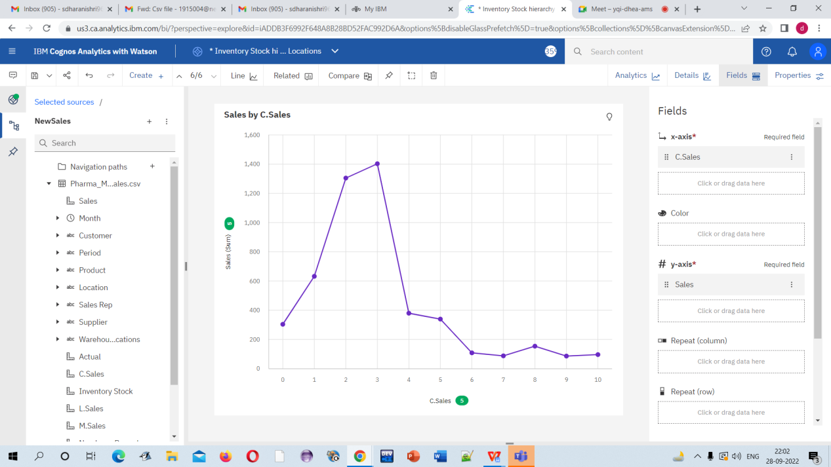

LINK:

<https://us3.ca.analytics.ibm.com/bi/?perspective=explore&pathRef=.my_folders%2FSales%2Bby%2BC.Sales&subView=model0000018384ef59a6_00000003>

MONTHLY SALES:

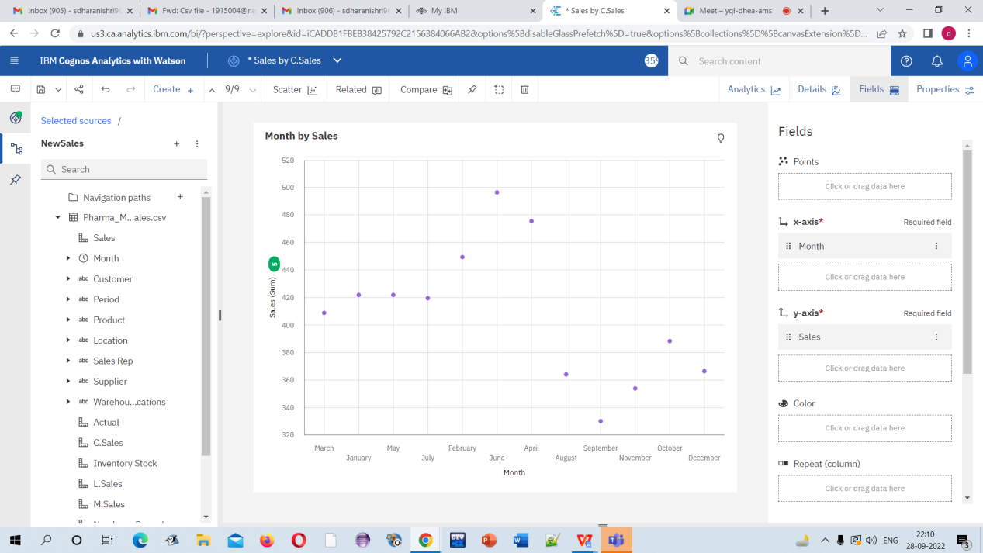

LINK:

<https://us3.ca.analytics.ibm.com/bi/?perspective=explore&pathRef=.my_folders%2FMonth%2Bby%2BSales&subView=model0000018384f78a21_00000004>

8.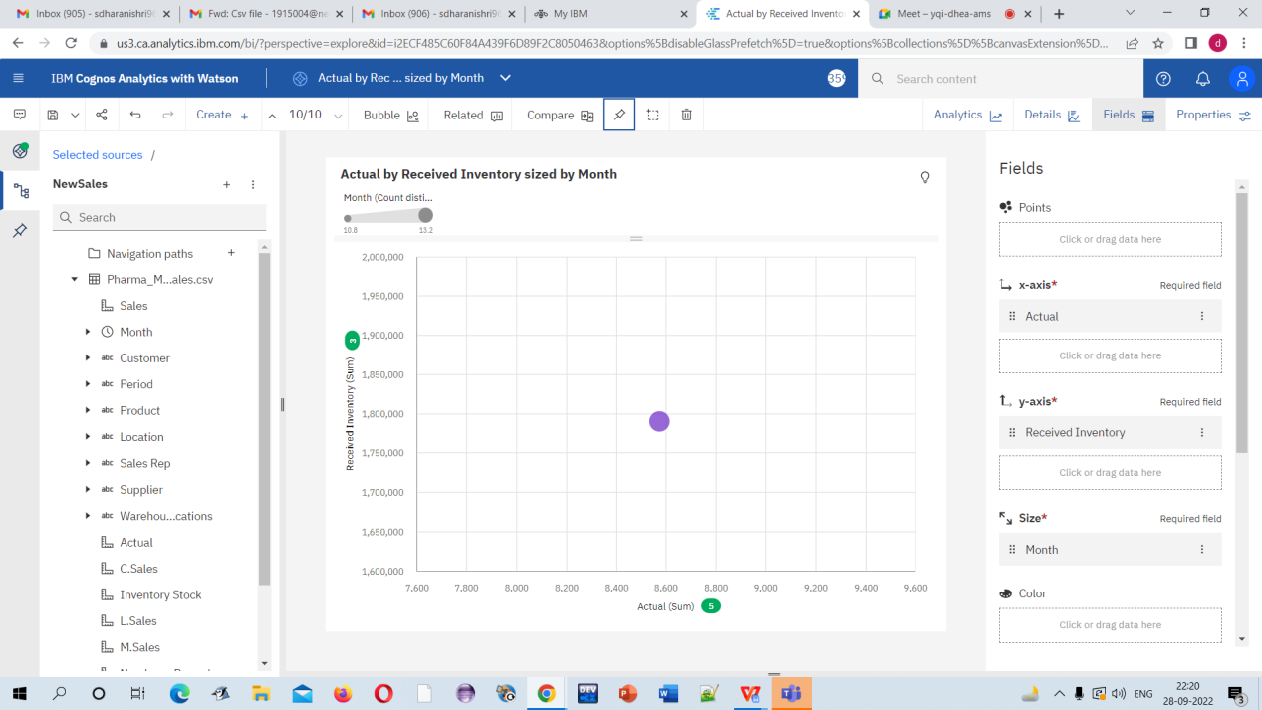

LINK

<https://us3.ca.analytics.ibm.com/bi/?perspective=explore&pathRef=.my_folders%2FActual%2Bby%2BReceived%2BInventory%2Bsized%2Bby%2BMonth&subView=model0000018384fa24a9_00000000>

9

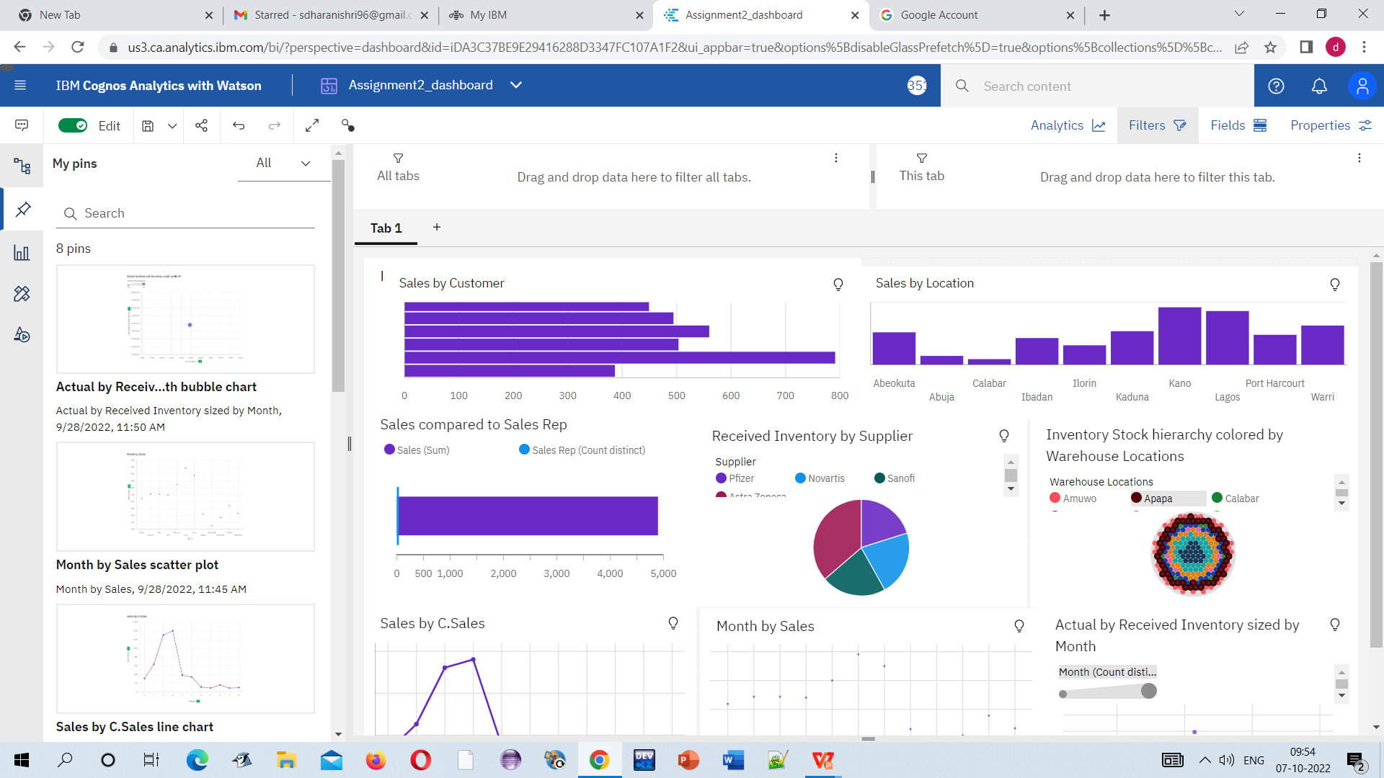

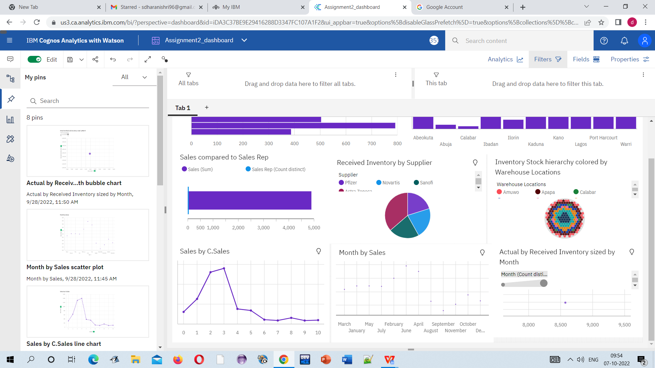

Screenshot link:

<https://us3.ca.analytics.ibm.com/bi/?perspective=dashboard&pathRef=.my_folders%2FAssignment2_dashboard&action=view&mode=dashboard&subView=model00000183b0a7a362_00000000>